**MySQL ACTIVITY**

1. Create database and Table with fields: 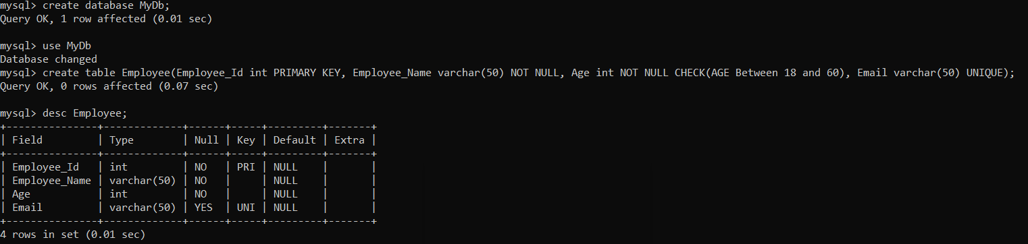
2. Store the records in the above employee table & try to store age 70 and age 17 and see what happens: 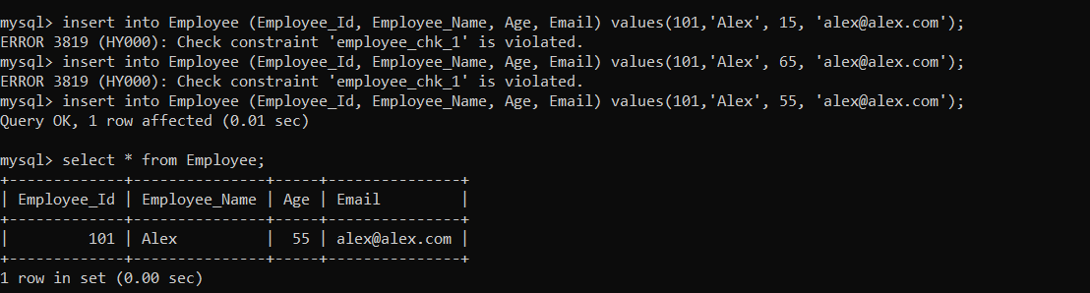
3. Store the few more records in the above employee table & try to store same email to multiple records and observe what happens



1. Alter the above employee table add two new columns pan and aadhar

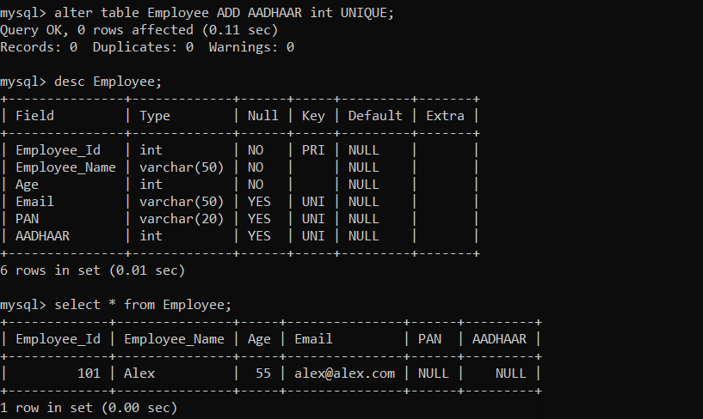

1. Insert few records in employee table and observe the result, try to pass duplicate aadhar or pan and observe the result. 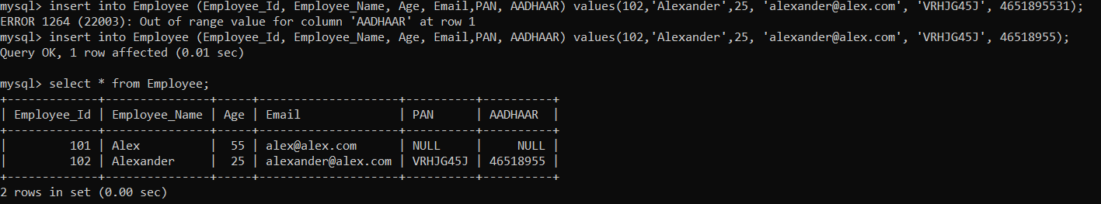
2. Alter the above employee table and remove the pan and aadhar columns

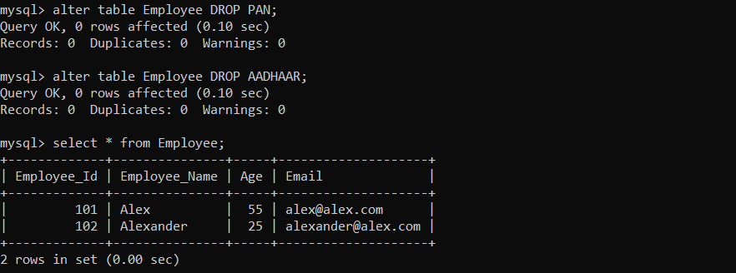

1. Using the DROP delete the employee table: 